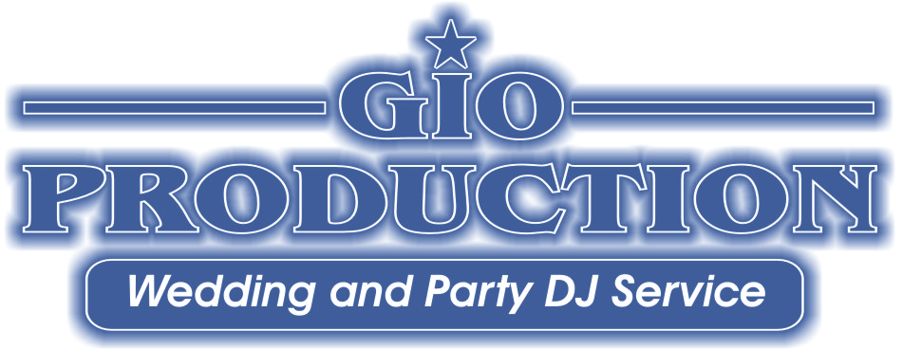

WEDDING ANNOUNCEMENT SHEET

BRIDE’S NAME: ________________________________________ WEDDING DATE:_ _________ TIME: ______________

GROOM’S NAME PLACE OF WEDDIING: ________ _______________

PHOTOGRAPHER : __________________________________ VIDEOGRAPHER:

NUMBER OF GUESTS: _________________ AVERAGE AGE: ____________________

INTRO SONG FOR PARENTS: __________________________________________________ ARTIST: _______________________________________________

GRANDPARENTS OF THE BRIDE: _____________________________________________________________________________________________________

GRANDPARENTS OF THE GROOM: ____________________________________________________________________________________________________

PARENTS OF THE BRIDE: MR & MRS. _________________________________________________________________________________________________

MOTHER: _______________________________________________________ ESCORTED BY: ______________________________________________________

FATHER : ________________________________________________________ESCORTED BY: ______________________________________________________

PARENTS OF THE GROOM: MR & MRS. _________________________________________________________________________________________________

MOTHER: ESCORTED BY: _______________________________________________________

FATHER: ESCORTED BY: ________________________________________________________

INTRO SONG (S) FOR BRIDAL PARTY: ______________________________________________ ARTIST:

BRIDESMAID: _____________________________________________________ GROOMSMAN

BRIDESMAID: ___________________________________________________ GROOMSMAN

BRIDESMAID: _______________________________________________ GROOMSMAN

BRIDESMAID: _____________________________________________________GROOMSMAN

FLOWER GIRL: _________________________________________________ RINGBEARER________________________________________________________

MAID/MATRON OF HONOR: BEST MAN: _______________________________________________________

INTRO SONG FOR BRIDE &GROOM: ARTIST:

(BRIDE AND GROOM) MR & MRS.________________________________________________________________________________________________________

PLEASE “X” YES OR NO FOR THE FOLLOWING OPTIONS

YES NO FIRST DANCE SONG: _____________________________________________ARTIST: ____________________________________________

SPECIAL INTRUCTIONS: _______________________________________________________________________________________________________

YES NO BRIDAL PARTY DANCE SONG: _______________________________________________ ARTIST: ________________________________

YES NO BLESSING/GRACE: ____________________________________________________________________________________________________

YES NO TOAST GIVEN BY: _____________________________________________________________________________________________________

DINNER MUSIC: ________________________________________________________________________________________________________________________

WEDDING ANNOUNCEMENTS
-2-

YES NO ANNIVERSARY DANCE SONG (S): _________________________________________ARTIST: _____________________________________

SPECIAL ANNOUNCEMENTS (ANNIVERSARIES, BIRTHDAYS, CENTERPIECE GIVAWAYS…) Write below:

YES NO CAKECUTTING SONG: ARTIST:

YES NO BRIDE / FATHER DANCE SONG: _________ARTIST: ____

YES NO GROOM / MOTHER DANCE SONG: ARTIST:

YES NO BOUQUET / GARTER SONG (S): ARTIST:

MUSIC : 40’s - 50’s - 60’s - 70’s - 80’s - 90’s - 00’s – Top 20 – classic rock – rock –country – disco – hip hop/rap

RADIO STATION YOU LISTEN TO?

DO NOT PLAY | MUST PLAY | BASIC REQUESTS
INTERACTIVE (ELECTRIC SLIDE, ETC) | SLOW MUSIC | SPECIALTY (ITALIAN, LATIN, ETC)

LAST SONG (S): ARTIST:

____________________________________ ________-___ _

